A Comprehensive Review of Feature Extraction Techniques in Image Processing

Abhinay Goswami, Divakar Sharma, Jay Kishor Thakur

*Department of Artificial Intelligence & Data Science, Galgotias College of Engineering & Technology Greater Noida*

*Address*

abhinay.21gcebaids059; divakar.21gcebaids009;[jay.21gcebaids026@galgotiacollege.edu](mailto:jay.21gcebaids026@galgotiacollege.edu)

***Abstract -*** Feature extraction plays a crucial role in executing diagnosis as well as classification, clustering, recognition and detection tasks. The investigation in this paper classifies the main feature extraction approaches across geometric, statistical, texture and color classifications. The methods receive a detailed presentation with definitions together with mathematical formulas and practical illustration examples. Tests conducted on face and plant images demonstrate different extraction results depending on the image type leading to substantial performance disparities. This review shows fundamental knowledge for future extraction methods and their use in multiple application areas.

***Keywords-*** Feature Extraction, Geometric Features, Statistical Features, Texture Features, Colour Features.

1. Introduction

Effective feature extraction techniques are crucial for accurately processing images in binary, colored, or grayscale formats. Such techniques allow proficient Authentication, categorization, evaluation, segmentation, interpretation and localization. This paper describes feature extraction methods as geometric, statistical, texture, and color features, with each feature being subdivided into further subtypes. The main focus is on the methodologies and application scopes of these techniques, along with experimental evaluations on different datasets.

Increasingly, computers are capable of deriving semantic concepts from an image through analysis without dependence on human knowledge. The initial step towards this understanding is the selection of efficient and effective visual features to maximize the success rate of an image processing task with a computer. Effective imagery features involve color, Pattern, structure, and form., all of which are important in the construction of reliable computer image processing system models[1-3].

In today's world, Remote Sensing is important for research and its uses are increasingly daily. RS technology property is based on two factors: first, it depends on the development area of sensors and RS platform [4]; second, it depends on the development area of RS image processing technology. On the other hand, The present processing rate of the RS image is much slower than the speed at which the sensor collects data. Along with the improvement of RS image resolution, image data amount has increased significantly and expanded dramatically[5], however the corresponding processing technology can hardly adapt to the real-time requirement. In most cases, image processing still rests on the visual inspection and experience interpretation stage.

Following Chart shows the most important features extraction methods.[15]

| Feature Vector | | | |
| --- | --- | --- | --- |
| Geometry | Statistical | Texture | Color |
| a.Area | a.Contrast | a.GLCM  1.Uncertainty 2.Difference 3.Association 4.Intensity 5.Uniformity | a. Color moment  1.Mean  2.Standard  Deviation  3.Skewness |
| b.Slope | b.Entropy |
| c.Perimeter Entropy | c.RMS |
| d.Centroid | d.Energy |
| e.Irregularity Index | e.Kurtosis | b.Color Histogram |
| f.Equivalent  Diameter | f.Correlation | c.Average RGB |
| g.Convex area | g.Variance | b.Tamura  1.Granularity 2.Difference 3.Orientation 4.Linear 5.Pattern 6.Consistency 7.Irregularity |
| h.Solidity | h.Fifth and Sixth Central, Moment |
| i.Smoothness |
| j.Mean |
| k.Standard Deviation |

* 1. Geometry Features

*1) Area:*  There are eight geometry feature types. These are:

Area is different from perimeter in that it scales by the amount of inner space that a figure contains. Geometric shapes such as triangles, circles and rectangles use known formulas that find their measurement of area. The section area for the irregular polygons needs a number integration method, so that it becomes the Gauss trapezoidal rule, as in Equation (1) of the paper [6].

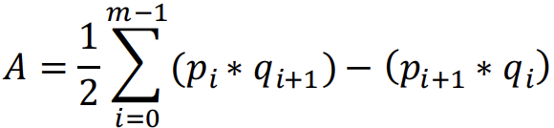 (1)

where: m → Total count of points, p → Coordinates along the X-axis, q → Coordinates along the Y-axis

2) Slope*:*  A straight line consists of a series of points with a constant slope between any two points. It is usually called the slope and is measured as the ratio of change in vertical displacement to the change in horizontal displacement. Using two points on the line, typically, to calculate the slope. A vertical line which followed by y-axis and horizontal line which parallel to x-axis has an undefined slope. In particular, equation (2) indicates that parallel lines have the same slope. [7]

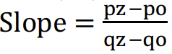 (2)

3) Perimeter: Every two-dimensional shape has a perimeter which serves as the complete length of its enclosing boundary both for basic figures and complex irregular shapes. Each regular polygon possessing equal sides uses Equation (3) to calculate its perimeter. Equation (4) serves to calculate the perimeter of irregular polygons containing different lengths of sides.

 (3)

 (4)

"Where: n (number of ribs), x (length of the rib)."

4) Centroid-An object has an internal centre point called the centroid, and that point is the intersection of different symmetry lines. It is a good representation of the object's center of mass or balance point. The centroid's exact location is determined by the object's shape and the mass distribution within it.

In (5) we have a way for the centroid to compute the coordinates.

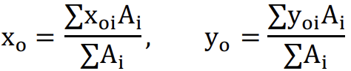 (5)

Where:

Xo: The x-coordinate of the shape's center point.

Yo: The y-coordinate of the shape's center point.

Xoi: The distance of the shape's center from the origin along the x-axis.

Yoi: The distance of the shape's center from the origin along the y-axis.

Ai: Region of the shape.

5) *Irregularity Index[8]:* The boundaries of irregular shapes is calculated by the Equation(6)

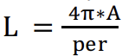 (6)

Where: A:is area, Per: is perimeter The metric value irregularity index (L) is equal to one only for the circle and it is < 1 for any other shape.

*6) Equivalent Diameter [9]:* A numerical value that defines the diameter of the circle in combination with the same space as the area. It is calculated as in the following Equation (7).

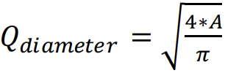 (7)

Where: **A** denotes the area.

*7) Convex Area:* A set of points in Euclidean space forms a closed convex set when it represents a geometric concept known as the convex set. A convex set represents the minimum size convex shape which contains a specific collection of points known as X.The evaluation of convex area counts pixel numbers that exist within the boundaries of the convex hull when analyzing digital images. The size of the bounding box depends on its dimensions as the smallest rectangle which contains the entire convex hull.

*8) Solidity:* Compute the pixel proportion in a convex hull within the area [10], Where: A denotes the area

 (8)

B. Statistical Features

This group of approaches bypasses direct analysis of texture hierarchy through its method of representing textures by statistical measurements of pixel intensity relationships. The collection of typical texture features includes eleven distinct elements which are Entropy, Contrast, Energy, Root Mean Square (RMS), Correlation, Kurtosis, Fifth and Sixth Central Moments, Variance, Mean, Smoothness, and Standard Deviation.

*1) Contrast:* The reference pixel contrast measurement depends on the difference between its gray-level value and its adjacent pixel value. The lightness of the object color and other display area items determine the amount of contrast according to Equation 9.

 (9)

The value for m stands at (i-j) when both (i) and (j) are identical which makes cells located Along the diagonal for i-j=0. The weight equals 1 when I and j have a difference of 1. A weight value of 4 exists when i and j possess a difference of 2 while the contrast level increases. The weight values rise exponentially with each increase in the value of (i − j).

*2) Entropy:* Entropy is used to evaluate system interruption in the physics of thermodynamics. Entropy measurement is the best method to evaluate the level of unstable signal interruption along with measuring the quantity of information within the event defined in Equation 10.

Entropy = -sum (P ∗ log (P)) (10)

Where: P denotes the probability vector.

*3) RMS(Root mean square error):* RMS(Root mean square error) produces ascending values when error develops yet fails to detect early fault stages while following Equation 11 for its calculation.

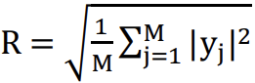 (11)

*4) Energy:* Energetic concepts are used to measure probabilistic information via MAP estimation and MRFs. The interpretation of energy shifts between maximizing positive values and minimizing negative values based on what problem requires solution. A comprehensive explanation regarding energy functions exists in reference Eq. [12].

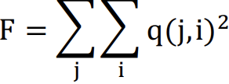 (12)

*5) Kurtosis:* The stability of distribution type can be measured by Kurtosis because it indicates the distance of a distribution from normal distribution.

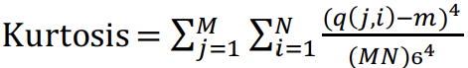 (13)

*6) Correlation:* The fundamental information extraction method for images is known as correlation which can be expressed as Equation 14.

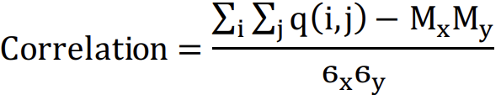 (14)

*7) Variance:* Variance stands for the mean of signal square values which appears after eliminating the mean value through Equation 15.

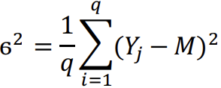 (15)

Where: ϭ denotes the variance, q denotes the no of samples, Yj denotes the input heart signal and μ denotes the mean

*8) Fifth and sixth central moment:* Fifth and sixth central moment measure deviations from average values.Fifth-order central moment, Sixth-order central moment.

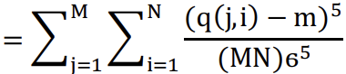 (16)

Sixth central moment

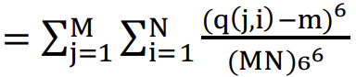 (17)

*9) Smoothness:* The value Q represents comparative smoothness through gray level disparity measurements for generating relative smoothness formulas. The smoothness value becomes known through Equation 18.

 (18)

Where, σ denotes the standard deviation of the picture.

*10) Mean:* compute the average values in the picture.

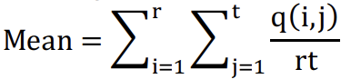 (19)

Where q(i, j) is the intensity value of the pixel at the point (i,j). The image is of r by t size.

*11) Standard Deviation:* Standard Deviation indicates the procedural measurement of pixel values distribution around their mean. A standard deviation which is low indicates pixels to be closely grouped at the mean value thus showing little contrast. When pixels display greater distribution the contrast becomes higher. The mathematical formula for this concept appears in Equation 20.

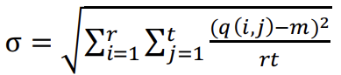 (20)

* 1. *Texture features*

The evaluation of images depends heavily on texture since it functions as a fundamental analytic attribute. Visual processing through the human brain heavily depends on texture properties for both recognition and interpretation of information. Casual patterns emerge from the spatial grouping of pixels instead of being an inherent quality of single pixels like color.

Various approaches exist that extract texture features from images. The extraction processes take place either in spatial domain or spectral domain space which leads to two broad classifications. The analysis of pixel values in original images through direct methods determines statistical measures and identifies local patterns in spatial domains. Pixels in spectral domain techniques get converted to frequency domain formats including Fourier or wavelet domains for feature analysis. Each method features different strengths and weaknesses that Table 1 summarizes effectively.

TABLE I

| **Variation in texture features** | | |
| --- | --- | --- |
| **Texture method** | **Pros.** | **Cons.** |
| Geometric texture | Significant, Understandable, can be extracted from any shape without losing info. | Sensitive to noise and disruption. |
| Geometric texture | Durable, need less calculation. | No semantic meaning, need square image regions with sufficient size |

In this paper, two types of texture features are discussed (GLCM and Tamura)

*1) Gray Level Co-occurrence Matrices (GLCM):* Gray Level Co-occurrence Matrices (GLCM) allow the analysis of image gray-level data distribution by using histograms at specific pixel offsets. The extraction of texture information for damaged tissue images happens through application of this method in reference.Contrast, Energy, Correlation, Homogeneity, and GLCM Entropy. represent five different texture features that this analysis method uses.

*1.1) Entropy:* A numerical analysis of unpredictability can be used to differentiate the pattern of a given image.

Entropy = -∑ ∑ q(i, j)logq(i,j) (21)

Where: q denotes the number of gray-level co-occurrence matrices in GLCM

*1.2) Contrast:* Compute the density contrast between adjacent pixels and pixels to the whole image. Equation 5 explains the contrast.

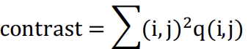 (22)

Where, q(i,j) = pixel at location (i,j).

*1.3) Correlation:* The function of this gauge is to compute the probability of the specified pixel pairs as in Equation 23.

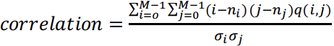 (23)

*1.4) Energy:* Is the summation of squared elements in the GLCM .It is also known as the angular second moment or uniformity.

 (24)

*1.5) Homogeneity:* Homogeneity is used to compute the estimation of the arrangement of components in the GLCM to the GLCM diagonal., which define in Equation 25.

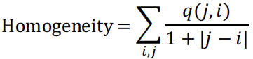 (25)

*2) Tamura:* Tamura created six measurement features used for different image types because his texture analysis system operates on multiple image types. The six different textures have particular values established through Coarseness, Roughness, Directionality, Tamura Contrast, Line-Likeness, and Regularity.[11]

*2.1) Coarseness:* Coarseness describes a texture feature which measures the dimensions of its fundamental elements that form a texture pattern. Within an image the spatial distribution of various gray levels plays an essential role in the coarseness measurement. The measure of dominant texture patterns within a given surface determines the scale and frequency which relate to coarseness.

The mathematical expression in Equation 26 potentially measures coarseness across two possible analysis methods which include spatial frequencies of image data and pixel intensity statistical distributions. The definition of coarseness extends beyond the largest scale because it can apply to multiple scales present in an image.

 (26)

In which: : denotes the size is the average of the surrounding area.

 (27)

Equation 27 computes the difference between pairs of averages corresponding to non-overlapping surrounding areas.

*2.2) Contrast:*Evaluation assignment of gray levels which change for extent is its spread into white or black. Compute the contrast, utilize the fourth-order central moments of gray levels and the second-order moments.

 (28)



In which, N₄ represents the fourth moment about the mean, and 2 denotes the variance. m = 1/4 provides the nearest value based on Tamura.

*2.3) Directionality:* Directionality serves as a texture feature to determine how many directional patterns exist throughout an image. The measure examines edge frequencies that extend throughout different directions within the image. The strength of linear or directional patterns corresponds directly to the value of directionality measurement. The feature detects patterns in both consistent and random or disordered textural images.



(29)

Where

Mp: mp denotes the number of total peaks.

bp: bp denotes is the alignment of the peak

wp: Wp represents the range of angles associated with the Pth peak.

r: The normalization term b represents the quantized angle levels while b stands for the direction angle that has been quantized.

H directionality:Represent the histogram of quantized direction values.

b : Is formed by counting the number of edge pixels with the corresponding directional angles.

*2.4) Line-Likeness:* Line-likeness pertains solely to the shape of the texture primitives. Line-like textures contain either straight or wavy primitive elements but their orientation remains unfixed. The majority of line-like textures present orientated functionally.

*2.5) Regularity:* The measure of regularity in images calculates constant patterns together with comparable elements according to definition 30..



(30)

The normalization factor R divides the calculation which contains the standard deviation from fxxx designated as Cxxx.

*2.6) Roughness:* Calculated as a sum of the measures of contrast and coarseness.

Roughness = Coarseness + contrast (31)

* 1. *Color Features*

The basic characteristic of images that shapes human understanding and visual processing is the element of color. A color space selection among RGB, LUV, HSV or HMMD greatly influences how features are defined and extracted. Among all color feature types, the color histogram stands out as the most popular because it shows the color frequency distribution patterns of images. The Color Moments (CM) methodology creates brief representations of color information through measures that include mean standard deviation and skewness values of color distribution. The Color Coherence Vectors (CCV) analyze color spatial arrangements and the Color Correlograms determine pair color spatial relationships. Color Moments (CM) represent an efficient method for acquiring color information through their basic yet efficient color measurement technique. This computational method serves multiple image analysis and computer vision applications and executes efficiently .[12-14]

TABLE II

| **Contrast of different color descriptors** | | |
| --- | --- | --- |
| **Color**  **method** | **Pros.** | **Cons** |
| Histogram | Easy to calculate, straightforward, understandable. | Large scale, lacks spatial information, prone to noise. |
| CM | Concise, resilient | Insufficient for representing all colors, lacks spatial information. |
| CCV | Geometric data | Large scale, extensive computational expense. |
| Correlogram | Geometric data | Extremely high computational expense, prone to noise, rotation, and scaling. |
| DCD | Concise, resilient, intuitive significance. | Requirement post-processing for geometric data. |
| CSD | Geometric data | Sensitive to noise, rotation and scale |
| SCD | Efficient when required, adaptable scalability. | No geometric data, less accurate if compact |

*1) Color Moments:* Images use distinct color patterns to achieve differentiation using color-based scales. The corresponding probability distribution values from the image constitute its Color Moments. The three color moments are mean, standard deviation, and skewness are as follows.

* 1. *Mean:* The mean remains the average color value in an image represented through Equation 32..

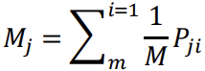 (32)

*1.2) Standard Deviation (STD):* It is the square root of the distribution variation that follows Equation 33.

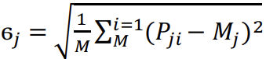 (33)

*1.3) Skewness:* The deviation calculation provides an indicator for distributing asymmetry between its statistical components.

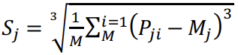 (34)

*2) Color Histogram:* The intuitive nature combined with substantial information dissemination has made color histograms one of the fundamental image characteristics researchers widely adopt.

Image color information gets frequently represented using color histograms.The statistical data about color distribution generated from images supports various analytical tasks such as classification, segmentation and retrieval.

*3) Average RGB:* The Average RGB parameter works as a formula to provide a precise fundamental view of the entire image color spectrum. This technique determines its operation through a mean algorithm applied to red, green, and blue color components. Average RGB enables image filtering processes and supports the classification of images. The technique transforms 2D and 3D images into a vector with 3 components which results in faster image processing and enables cluster formation through average color analysis.

1. Conclusions

An all-encompassing view of feature extraction methods and steps is analyzed based on imaging processes, particularly with geometric, statistical, texture, and color based approach methods. Every method has features and advantages along with application, hence researchers need to be careful while selecting these techniques as per the domain of issue. These methods are very important for areas like pattern analysis, medical imaging, or even computer intelligence applications for environmental control. Furthermore, the inclusion of features and satellite remote sensing indices as the Normalized Difference Water Index (NDWI) shows the expanded capabilities of feature extraction methods for analyzing satellite images to detect water bodies or perform land use classification. The study shows the importance of applying the distinctive characteristics and specialized techniques of every method in order to improve the effectiveness and precision of image processing tasks.

*Future Scope*

The field of feature extraction continues to evolve with advancements in machine learning and deep learning. Future research could focus on integrating traditional feature extraction methods with neural network-based techniques to enhance their capabilities. For instance, combining geometric and statistical features with convolutional neural networks (CNNs) may improve performance in remote sensing applications. Furthermore, the development of automated feature selection algorithms could streamline the process of identifying optimal features for specific tasks.

References

[1] *M. M. Islam, D. Zhang and G. Lu. “A geometric method to compute directionality features for texture images”, In Proc. ICME, (2008), pp. 1521-1524.*

[2] *S. Arivazhagan and L. Ganesan, “Texture classification using wavelet transform”, Pattern Recognition Letters, vol. 24, (2003), pp. 1513-1521.*

[3] *Kavya R and Harisha 2015 Feature Extraction Technique for Robust and Fast Visual Tracking: A Typical Review ( International Journal of Emerging Engineering Research and Technology Vol 3 Issue 1) PP 98-104,*

[4] *Jimenez-Munoz, Juan C.; Sobrino, Jose A.; Skokovic, Drazen et al. 2014. Land Surface Temperature Retrieval Methods from Landsat-8 Thermal Infrared Sensor Data. IEEE GEOSCIENCE AND RS LETTERS 11(10): 1840-1843.*

[5] *Pope, Allen; Rees, W. Gareth; Fox, Adrian J. et al. 2014. Open Access Data in Polar and Cryospheric Remote Sensing. Remote Sensing 6(7): 6183-6220.*

[6] *A. H. Stroud 1971 Approximate Calculation of Multiple Integrals( Prentice-Hall Inc., Englewood Cli_s, N. J.).*

[7] *Christopher Clapham, James Nicholson 2009 Oxford Concise Dictionary of Mathematics( OUP oxford).*

[8] *S. A. Patil and V. R. Udpi 2010 Chest x-ray features extraction for lung cancer classification( Journal of Scientific and Industrial Research Vol 69) pp 271-277.*

[9] *R. C. Gozalez and R. E. Woods 2002 Digital Image Processing Using Matlab, 2nd ed, Gatesmark ( USA) chapter 12 pp 642-654.*

[10] *K. P. Aarthy and U. S. Ragupathy 2012 Detection of lung nodule using multiscale wavelets and support vector machine( International Journal of Soft Computing and Engineering (IJSCE) Vol 2, Issue 3).*

[11] *A. K. Jain and A. Vailaya, “Image retrieval using colour and shape”, Pattern Recognition, vol. 29, no. 8, (1996), pp. 1233-1244.*

[12] *M. Flickner, H. Sawhney, W. Niblack, et al., “Query by image and video content: the QBIC system”, IEEE Computer, vol. 28, no. 9, (1995), pp. 23-32.*